Learning at JIS – from Cath Wan PYP Coordinator
This week we will address the next most popular question from parents: how do we develop critical thinking?
According to the Foundation for Critical Thinking, a critical thinker does the following:
- Raises vital questions and problems, formulating them clearly and precisely
- Gathers and assesses relevant information, using abstract ideas to interpret it effectively
- Comes to well-reasoned conclusions and solutions, testing them against relevant criteria and standards
- Thinks open mindedly within alternative systems of thought, recognizing and assessing, as needs be, their assumptions, implications, and practical consequences
- Communicates effectively with others in figuring out solutions to complex problems
(2017, Foundation for Critical Thinking)

Here are a few ways we develop these essential habits:
- The planned curriculum
- Supporting the students in ‘digging deeper’.
- Our interactions with the children: what we choose to say and not say.
- Experiences outside the classroom

The planned curriculum
The PYP curriculum provides a conceptual structure, within which students are expected to initiate and follow their own inquiries: asking questions, gathering and interpreting their research. In a transdisciplinary programme (see newsletter of October 5th), students are expected to solve complex problems which require them to make connections across disciplines. The emphasis away from passive learning (regurgitating facts which the teacher as ‘spoon fed’ them) and towards active learning (being supported to find out for themselves) continuously encourages critical thinking. An example of this type of learning comes this week from P5. Students are learning how to write a report. Passive learning might involve students being given a list of criteria and then producing their own. Instead, Mr. C had his students read, analyze and annotate a variety of reports. From this they will produce a list of criteria for effective report writing. The depth of thinking is completely different.
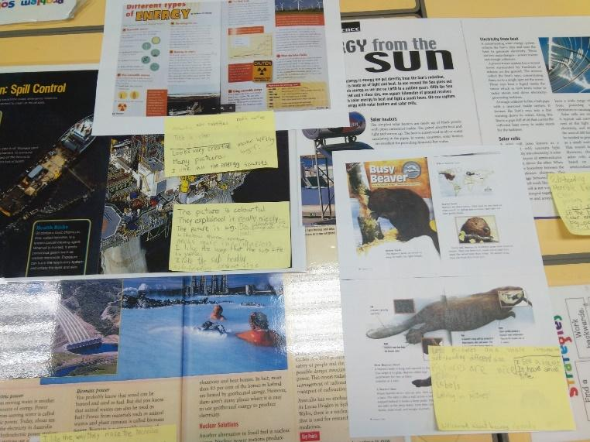

Supporting the students in digging deeper
At the moment, 7 of our teachers are taking a Harvard Graduate School online course called ‘Visible Thinking’. Mr. W and I also took the course previously and it was very helpful in providing practical ways of drawing out the students thinking. Once a student’s thinking has been made explicit, it becomes easier for both teacher, student and peers to examine the thinking and challenge it in different ways. The course uses a variety of ‘thinking routines’ to support and build thinking. For example, the ‘see think wonder’ routine that you will often see around school is a routine which has students observe in detail, notice their own thinking about their observations and then provoke questions to take them further. The ‘circle of viewpoints’ routine supports students in examining issues from different perspectives.
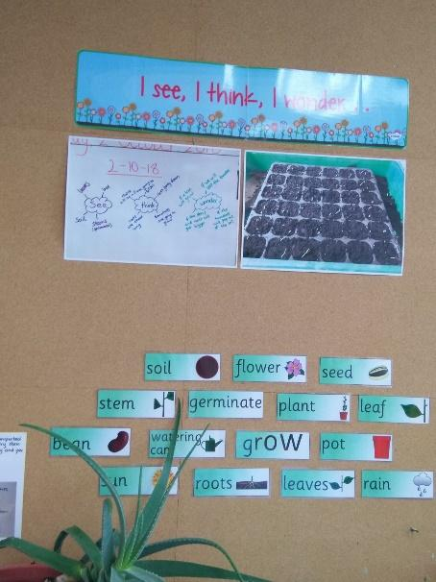

Our interactions with children
Students often want to know if they are right or wrong; for example, after solving a mathematical problem they will often ask “am I right?” A simple “yes” or “no” finishes that question, but ‘”mmm, I notice xxx has got a different result, please go and compare”, sets of a whole new layer of thinking with students trying to convince each other that their thinking is accurate. They naturally refine and adapt their thinking during this process. Another phrase that you will hear teachers saying is “what makes you say that?” Again, this gives the expectation that students should be able to explain and justify their reasoning.
Questioning is a skill that all teachers develop throughout their career, but as parents, questions in everyday conversation can really add to a child’s thinking skills. Here are a few question stems to get you started:
- What to do you think about….can you explain why you think that?
- Can you think about that from the viewpoint of…..how does it differ to your own viewpoint?
- Can you prove….to me/ convince me (great for mathematics!)
Moving away from “right and wrong” to “I have a different result/ opinion/ let’s compare/ convince me!/ can you prove it?” is not ignoring mistakes, it is using them as a deep and meaningful learning experience. Often halfway through convincing you of their reasoning, a child will realise where the error lays and self-correct it. It is an exciting ‘lightbulb’ moment to observe when a child does this. This is active thinking. Just hearing a “wrong or right” stops this wonderful process in its tracks.

Experiences outside the classroom
Taking students out of the classroom really develops their critical thinking skills. A few weeks ago, P6 visited a shopping mall to critically analyse how advertising works. It was fascinating to realise how clever the advertising is and how susceptible to it we are! Students in P2 class are currently planning a trip to Hong Kong Island. Each group will use a different combination of public transport which they have planned themselves using maps and transport timetables.

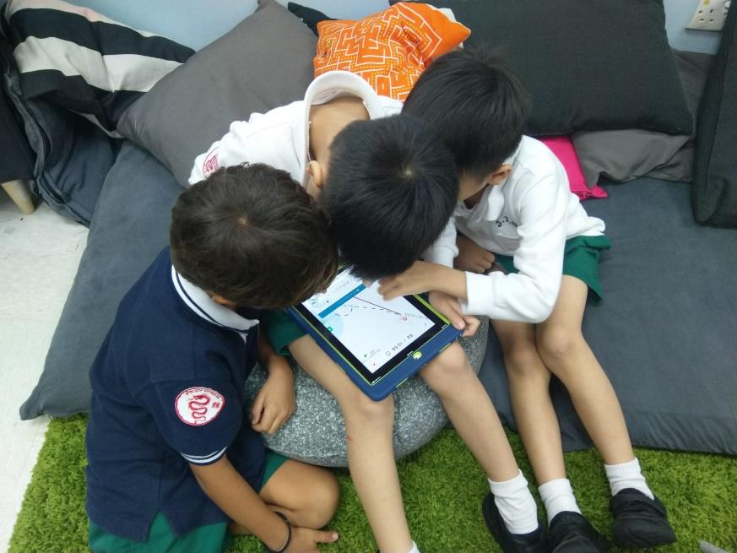

Our trips to the forest and our school camps are proving to be a wonderful way to develop critical thinking skills. Children tend to be naturally fascinated and curious about nature and how to interact with it.
- How do I get over the stream/ over the big muddy puddle without falling in it?
- How do I balance these stones in a tower so that they don’t fall down?
- How can I make a twig boat that will flow down the stream quickly?
- How do I arrange my possessions in my backpack?
- How do we work together to build a xxx?
These may seem like simple questions, but for a young child, these are foundational thinking skills; they are playing with and analyzing different options!

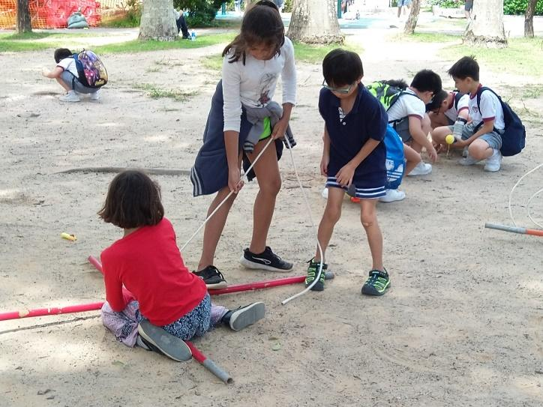
Yesterday, it was an absolute joy to accompany Reception class to Tai Po Kau. Thinking skills I observed included 2 children making a boat out of stones and discussing whether it would float or not. This was followed by a student initiated exploration of sinking and floating in the stream. One child found an interesting seed pod, found a way to open it and examine its contents. The whole trip was full of observations, questions and playing with ideas – the very core of critical thinking!
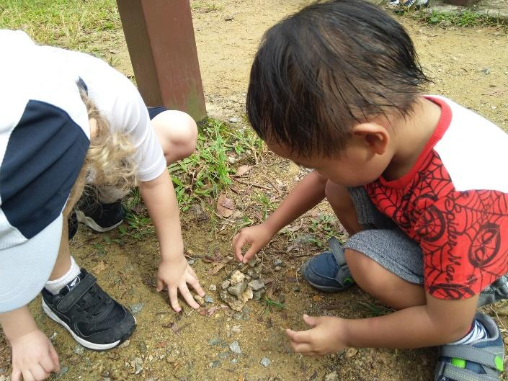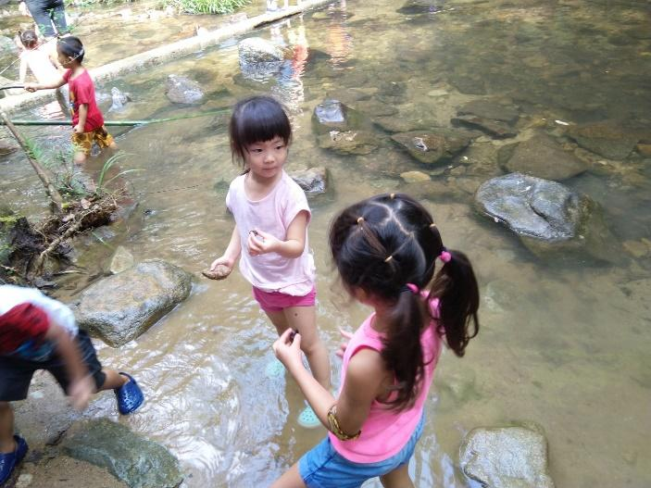

Further reading:
If you are interested in the development of critical thinking, these websites have some great information. Enjoy!
http://www.criticalthinking.org
https://philosophy.hku.hk/think/critical/ct.php
As always, feel free to email me with any questions or comments regarding learning at:

